**MINI PROJECT**

**BUS RESERVATION SYSTEM**

**AIM:**

To perform a mini project on the basis of the bus reservation system.

**DESCRIPTION ABOUT THE MINI PROJECT:**

The main aim of the mini project is to book the tickets for bus via approaching the travel agency where the incharge person would book the tickets according to the customers reqirement the mini project mainly consists of bus ticket booking ,cancellation,installation and display of all the customers who have booked the tickets in the in the specific bus routes

**SOURCE CODE**

/*This is the mini project based on the BUS RESERVATION SYSTEM */

#include <stdio.h>

#include <stdlib.h>

#include <string.h>

char ch[10][130]={"jarvis travels","kapoor Tours and Travels","AMC travels","pick and drop","GRC travels"};

char name[32][100]={'\0'};

char number[32][2]={'\0'};

int num1[32]={0};

int trno;

void bus();

void name_number(int booking,char numstr[100]);

void booking();

int read_number(int trno);

void read_name(int trno);

void status();

void status_1(int trno);

void cancel();

void login();

int main()

{

printf("THIS PROGRAM IS THE MINI PROJECT BASED ON THE BUS RESERVATION SYSTEM ");

//login();

int num,i;

do{

//system("cls");

printf("\n\n\n");

printf("**************** WELCOME TO THE BUS RESERVATION SYSTEM ******************\n\n\n");

printf("\t\t\t\t\t 1. View Bus List\n");

printf("\n");

printf("\t\t\t\t\t 2. ticket booking\n");

printf("\n");

printf("\t\t\t\t\t 3. cancellation of tickets\n");

printf("\n");

printf("\t\t\t\t\t 4. status of bus\n");

printf("\n");

printf("\t\t\t\t\t 5. Exit from reservation system\n\n");

printf("_______________________________________________________\n\n");

printf("\t\t\tEnter Your Choice:: ");

scanf("%d",&num);

switch(num)

{

case 1:

bus();//for list of bus

break;

case 2:

booking();//for booking the tickets

break;

case 3:

cancle();

break;

case 4:

status();

break;

}

getch();

}while(num != 5);

//system("CLS");

printf("\t__________________________________________________________________\n");

printf("\t\t\t\t\tThank You For Using our reservation System\t\t\t\t\t\t\n");

printf("\t_______________________________________________________________________\n");

getch();

return 0;

}

void bus()

{

//system("cls");

printf("\n\n\n");

printf("*******************BUS RESERVATION SYSTEM*******************\n\n\n");

printf("\t\t\t\t\t[1] => %s\n",ch[0]);

printf("\n");

printf("\t\t\t\t\t[2] => %s\n",ch[1]);

printf("\n");

printf("\t\t\t\t\t[3] => %s\n",ch[2]);

printf("\n");

printf("\t\t\t\t\t[4] => %s\n",ch[3]);

printf("\n");

printf("\t\t\t\t\t[5] => %s\n",ch[4]);

}

void booking()

{

int i=0;

char numstr[100];

//system("cls");

printf("******************* BUS RESERVATION SYSTEM*******************\n\n\n");//for entering train number

bus();//for seeing train least

printf("Enter the Bus number:--->");

scanf("%d",&trno);

//system("cls");

printf("******************* BUS RESERVATION SYSTEM *******************\n\n\n");//for selecting coach

printf("Your Bus Number is %d ********** %s",trno,ch[trno-1]);

status_1(trno);

FILE *f1, *fopen();//for reading the seats from the user.

char str1[80]="32",str2[4],str3[4];

int seat1,seat2,booking=0;

if(trno == 1)

{

f1 = fopen("tr1.txt","r+");

fgets(str1,80,f1);

fclose(f1);

}else if(trno == 2)

{

f1 = fopen("tr2.txt","r+");

fgets(str1,80,f1);

fclose(f1);

}else if(trno == 3)

{

f1 = fopen("tr3.txt","r+");

fgets(str1,80,f1);

fclose(f1);

}

else if(trno == 4)

{

f1 = fopen("tr4.txt","r+");

fgets(str1,80,f1);

fclose(f1);

}

else if(trno == 5)

{

f1 = fopen("tr5.txt","r+");

fgets(str1,80,f1);

fclose(f1);

}

seat1=atoi(str1);

if(seat1 <= 0)

{

printf("There is no blank seat in this bus ");

}else

{

printf("\n\n\n\t\t\t\tAvailable Seats:------>%d\n",seat1);

printf("\n\t\t\t\tNumber of Tickets:----->");

scanf("%d",&booking);

printf("\n");

seat1=seat1-booking;

itoa(trno,numstr,10);

name_number(booking,numstr);

printf("\n\t\t\t\tThe Total booking amount is %d",200*booking);

itoa(seat1, str1, 10);

if(trno == 1)

{

f1 = fopen("tr1.txt","w");

fputs(str1,f1);

fclose(f1);

}

else if(trno == 2)

{

f1 = fopen("tr2.txt","w");

fputs(str1,f1);

fclose(f1);

}

else if(trno == 3)

{

f1 = fopen("tr3.txt","w");

fputs(str1,f1);

fclose(f1);

}

else if(trno == 4)

{

f1 = fopen("tr4.txt","w");

fputs(str1,f1);

fclose(f1);

}

else if(trno == 5)

{

f1 = fopen("tr5.txt","w");

fputs(str1,f1);

fclose(f1);

}

}

}

void name_number(int booking,char numstr[100])

{

char tempstr[100],tempstr1[12]="status",tempstr2[12]="number", content1[100], content2[100], seatnumstr[100], inputstr[100], prevstr[100];

int number;

FILE *a,*b;

int i=0;

strcat(numstr,".txt");

strcat(tempstr1,numstr);

strcat(tempstr2,numstr);

a = fopen(tempstr1,"r+");

fgets(content1,100,a);

printf("File booking content 1 - %s",content1);

fclose(a);

b = fopen(tempstr2,"r+");

fgets(content2,100,b);

printf("File booking content 2 - %s",content2);

fclose(b);

a = fopen(tempstr1,"a");//for open the file to write the name in the file

b = fopen(tempstr2,"a");

memset(inputstr,0,strlen(inputstr));

memset(prevstr,0,strlen(prevstr));

memset(seatnumstr,0,strlen(seatnumstr));

for(i=0; i<booking; i++)//for entering the person name and seat number in the file

{

printf("*******************Enter the details for ticket no %d*******************\n\n\n",i+1);

printf("\t\t\t\tEnter the seat number:--->");

scanf("%d",&number);

strcpy(prevstr, seatnumstr);

itoa(number,seatnumstr,100);

strcat(inputstr, prevstr);

printf("Input dtring is %s\n", inputstr);

while(strstr(content2, seatnumstr) != NULL || strstr(inputstr, seatnumstr) != NULL) {

printf("Seat number %d is already booked. Please choose another seat", number);

printf("\t\t\t\tEnter the seat number:--->");

scanf("%d",&number);

itoa(number,seatnumstr,100);

}

printf("\t\t\t\tEnter the name of person:--->");

scanf("%s",name[number-1]);

printf("\n*********************************************************\n\n");

printf("\n");

itoa(number, tempstr, 10);

fprintf(a,"%s ",name[number-1]);

fprintf(b,"%s ",tempstr);

}

fclose(a);

fclose(b);

}

int read_number(int trno)

{

char tempstr[100],tempstr2[12]="number";

FILE *a,*b;

char numstr[100];

int i=0,j=0,k;

itoa(trno,numstr,10);

strcat(numstr,".txt");

strcat(tempstr2,numstr);

a = fopen(tempstr2,"a+");

while(!feof(a))

{

number[i][j] = fgetc(a);

if(number[i][j] == ' ')

{

j=0;

i++;

}

else

{

j++;

}

}

k=i;

for(i=0; i<k; i++)

{

num1[i] = atoi(number[i]);

}

fclose(a);

return k;

}

void read_name(int trno)

{

char tempstr1[12]="status";

FILE *b;

char numstr[100];

int i=0,j=0,k=0;

itoa(trno,numstr,10);

strcat(numstr,".txt");

strcat(tempstr1,numstr);

b = fopen(tempstr1,"a+");//for open the file to write the name in the file

while(!feof(b))

{

name[i][j] = fgetc(b);

if(name[i][j] == ' ')

{

j=0;

i++;

}

else

{

j++;

}

}

name[i][j]='\0';

k=i;

fclose(b);

}

void status()

{

//system("cls");

printf("*******************BUS RESERVATION SYSTEM *******************\n\n\n");

int i,trno,index=0,j;

printf("Enter the number of bus:---->");

scanf("%d",&trno);

j=read_number(trno);

read_name(trno);

printf("_______________________________________________________________________________________________\n");

printf(" Bus.no-->%d---->%s \n",trno,ch[trno-1]);

printf("_________________________________________________________________________________________________\n");

char tempname[33][10]={"Empty ","Empty ","Empty ","Empty ","Empty ","Empty ","Empty ","Empty ","Empty ","Empty ","Empty ","Empty ","Empty ","Empty ","Empty ","Empty ","Empty ","Empty ","Empty ","Empty ","Empty ","Empty ","Empty ","Empty ","Empty ","Empty ","Empty ","Empty ","Empty ","Empty ","Empty ","Empty ","Empty "};

for(i=0; i<j; i++)

{

strcpy(tempname[num1[i]],name[i]);

}

for(i=0; i<8; i++)

{

printf("\t\t\t\t");

for(j=0; j<4; j++)

{

printf("%d.%s\t",index+1,tempname[index+1]);

index++;

}

printf("\n");

}

}

void status_1(int trno)

{

printf("Your Bus Number is %d ********** %s",trno,ch[trno-1]);

//system("cls");

printf("******************* BUS RESERVATION SYSTEM *******************\n\n\n");

int i,index=0,j;

j=read_number(trno);

read_name(trno);

char tempname[33][10]={"Empty ","Empty ","Empty ","Empty ","Empty ","Empty ","Empty ","Empty ","Empty ","Empty ","Empty ","Empty ","Empty ","Empty ","Empty ","Empty ","Empty ","Empty ","Empty ","Empty ","Empty ","Empty ","Empty ","Empty ","Empty ","Empty ","Empty ","Empty ","Empty ","Empty ","Empty ","Empty ","Empty "};

for(i=0; i<j; i++)

{

strcpy(tempname[num1[i]],name[i]);

}

for(i=0; i<8; i++)

{

printf("\t\t\t\t");

for(j=0; j<4; j++)

{

printf("%d.%s\t",index+1,tempname[index+1]);

index++;

}

printf("\n");

}

}

void cancle()

{

int seat_no,i,j;

char numstr[100],tempstr2[15]="number",tempstr1[15]="status";

printf("Enter the bus number:---->");

scanf("%d",&trno);

itoa(trno,numstr,10);

strcat(numstr,".txt");

strcat(tempstr1,numstr);

strcat(tempstr2,numstr);

read_number(trno);

read_name(trno);

status_1(trno);

printf("Enter the seat number:--->");

scanf("%d",&seat_no);

FILE *a,*b;

a = fopen(tempstr1,"w+");

b = fopen(tempstr2,"w+");

for(i=0; i<32; i++)

{

if(num1[i] == seat_no)

{

for(j=0; j<32; j++)

{

if(num1[j] != seat_no && num1[j] != 0)

{

fprintf(b,"%d ",num1[j]);

fprintf(a,"%s",name[j]);

}

else if(num1[j] == seat_no && num1[j] != 0)

{

strcpy(name[j],"Empty ");

}

}

}

}

fclose(a);

fclose(b);

printf("\n\n");

printf("____________________________________________________________\n");

printf("\t\t\t\tYour 200 rupees has been Returned\t\t\t\n");

printf("___________________________________________________________\n");

}

void login()

{

int a=0,i=0;

char uname[10],c=' ';

char pword[10],code[10];

char user[10]="user";

char pass[10]="pass";

do

{

//system("cls");

printf("\n ========================= LOGIN FORM ========================= ");

printf(" \n ENTER USERNAME:-");

scanf("%s", &uname);

printf(" \n ENTER PASSWORD:-");

while(i<10)

{

pword[i]=getch();

c=pword[i];

if(c==13) break;

else printf("*");

i++;

}

pword[i]='\0';

//char code=pword;

i=0;

//scanf("%s",&pword);

if(strcmp(uname,"user")==0 && strcmp(pword,"pass")==0)

{

printf(" \n\n\n WELCOME TO OUR SYSTEM !!!! LOGIN IS SUCCESSFUL");

printf("\n\n\n\t\t\t\tPress any key to continue...");

getch();//holds the screen

break;

}

else

{

printf("\n SORRY !!!! LOGIN IS UNSUCESSFUL");

a++;

getch();//holds the screen

}

}

while(a<=2);

if (a>2)

{

printf("\nSorry you have entered the wrong username and password for four times!!!");

getch();

}

//system("cls");

}

**SNAPSHOTS OF THE OUTPUTS:**

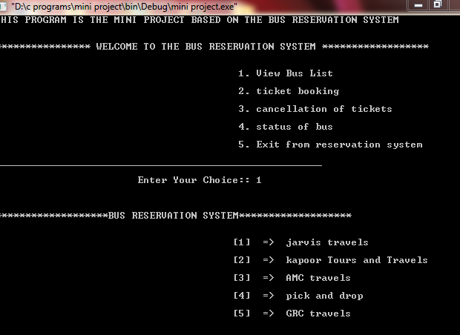

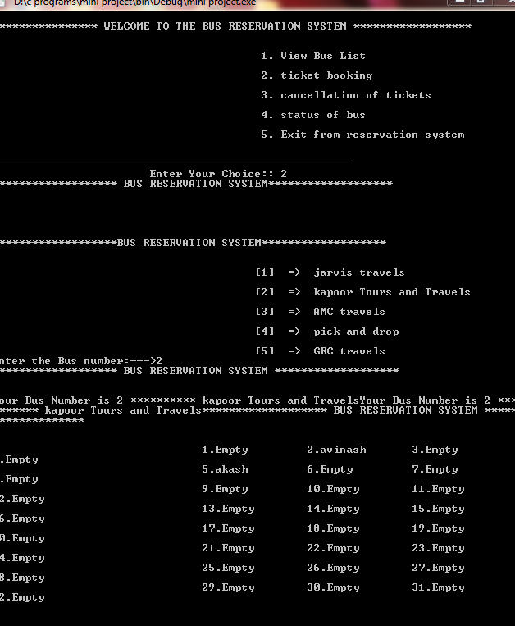

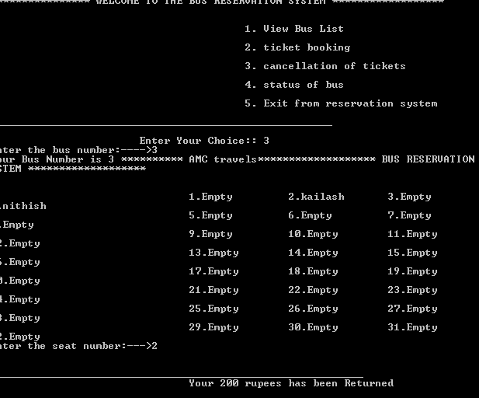

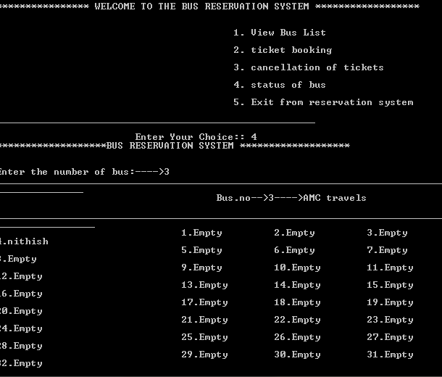

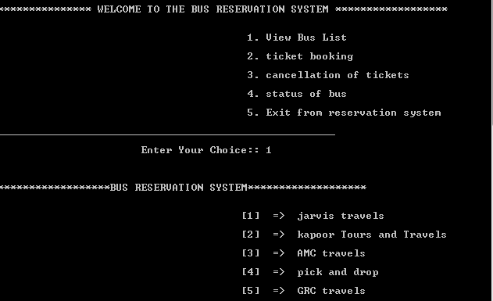

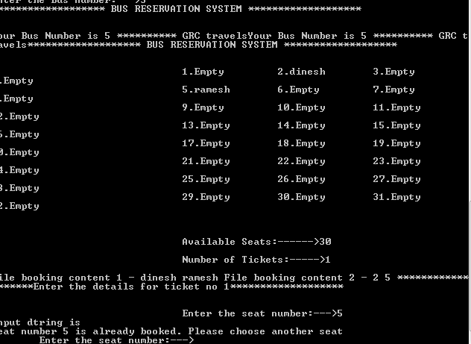

**RESULT:**

The above mini project has been successfully developed demonstrated and execueted.